Relational Databases with MySQL Week 4 Coding Assignment

**Points possible:** 70

|  |  |  |
| --- | --- | --- |
| Category | Criteria | % of Grade |
| Functionality | Does the code work? | 25 |
| Organization | Is the code clean and organized? Proper use of white space, syntax, and consistency are utilized. Names and comments are concise and clear. | 25 |
| Creativity | Student solved the problems presented in the assignment using creativity and out of the box thinking. | 25 |
| Completeness | All requirements of the assignment are complete. | 25 |

**Instructions:** Using a text editor of your choice, write the queries that accomplishes the objectives listed below. Take screenshots of the queries and results and paste them in this document where instructed below. Create a new repository on GitHub for this week’s assignments and push this document, with your Java project code, to the repository. Add the URL for this week’s repository to this document where instructed and submit this document to your instructor when complete.

**Coding Steps:**

Write 5 stored procedures for the employees database.

1. GetEmployeesTitleSalaryByDept_Name
2. GetCurrentSalaryBytitle
3. LocateEmployeeTitleDeptName
4. MaxSalaryByTitle
5. GetListOfDeptMangersByDeptName

Write a description of what each stored procedure does and how to use it.

1. Created a stored procedure to get a list of the employees first name, last name, title and salary. To use, need to type Call GetEmployeeTitleSalaryByDept_name(“ *and enter the desired dept name you would like to see the info”*). My example used the sales dept.
2. Created a stored procedure to get a list of titles and salaries for the last 20 years. To use need to type CALL GetCurrentSalaryByTitles (“*and enter the desired title you would like to see* “); My example used Staff.
3. Created a stored procedure to get a list of Employees by Dept_name, first name, last name and title. To use need to type CALL LocateEmployeeTitleDeptName (“*and enter the desired dept_name you would like to see* “); My example used Customer Service.
4. Created a stored procedure to get the max salary for an employee by the job title. To use need to type CALL MaxSalaryByTitle (“*and enter the title you would like to see and @maxSalary); SELECT @maxSalary*); My example used Senior Staff.
5. Created a stored procedure to get a list of first name, last name, employee by dept name. To use need to type CALLGetListOfDeptMangersByDeptName (“*and enter the dept name);* My example used Customer Service.

Procedures should use constructs you learned about from your research assignment and be more than just queries.

**Screenshots:**

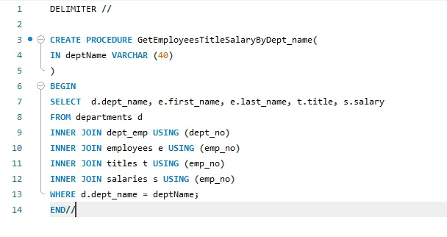

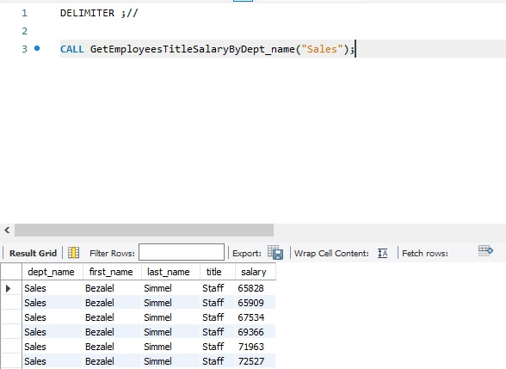

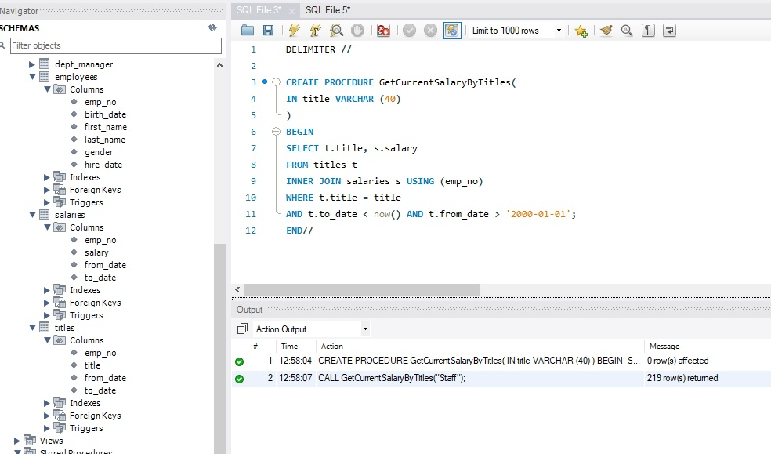

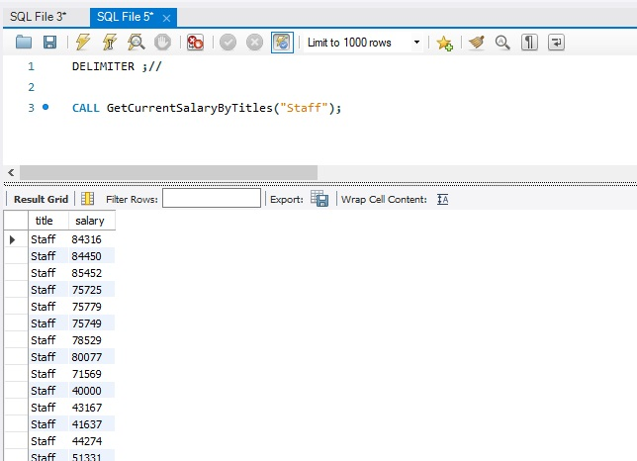

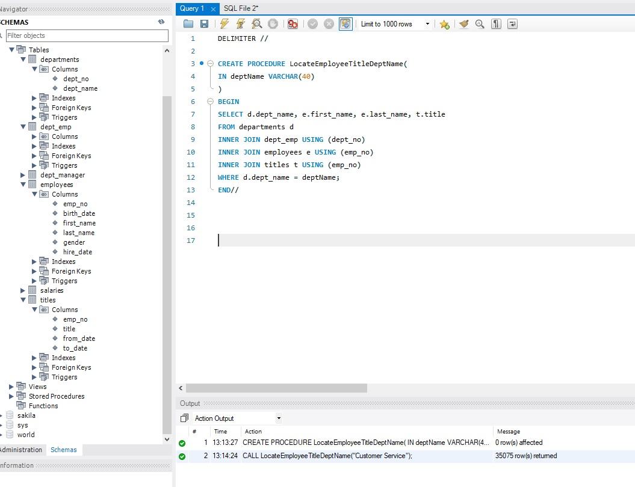

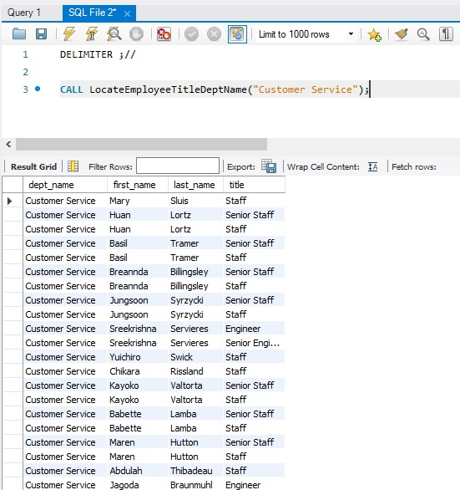

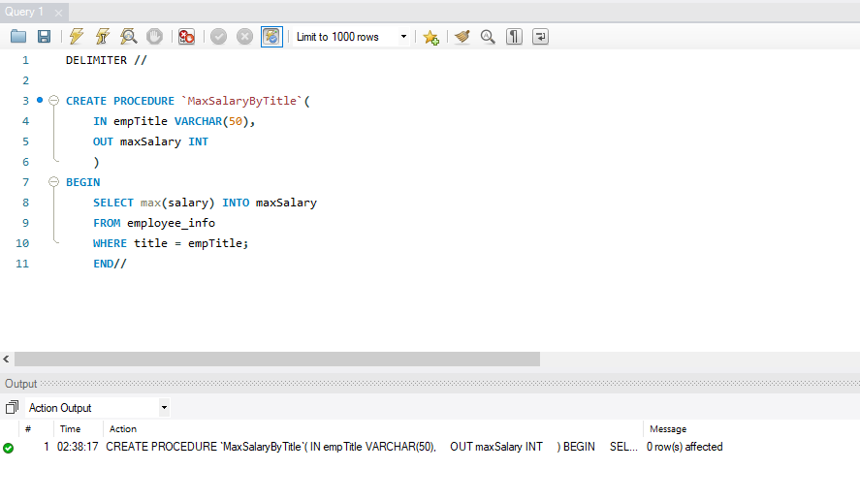

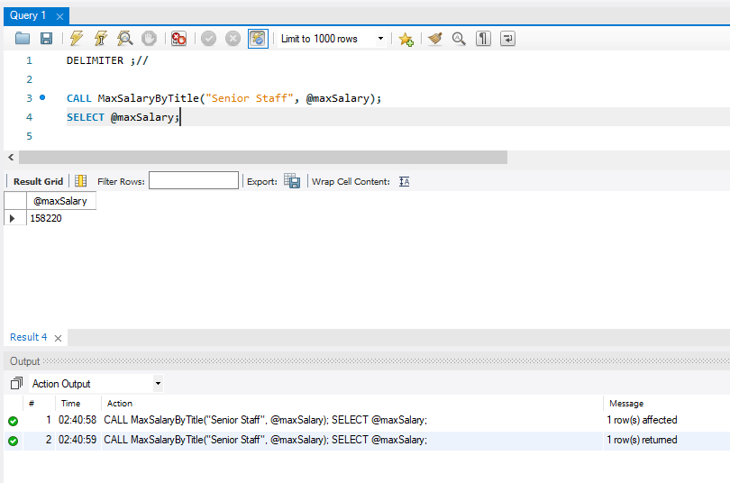

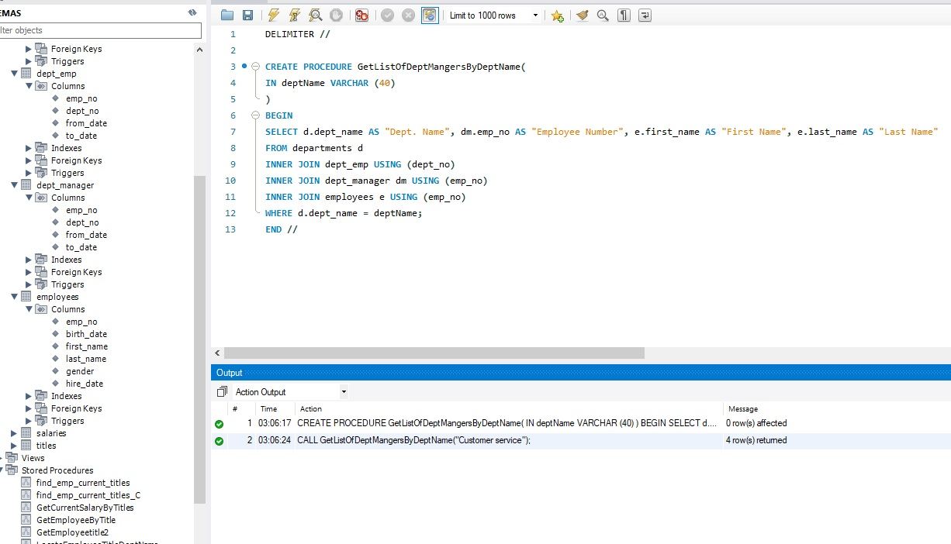

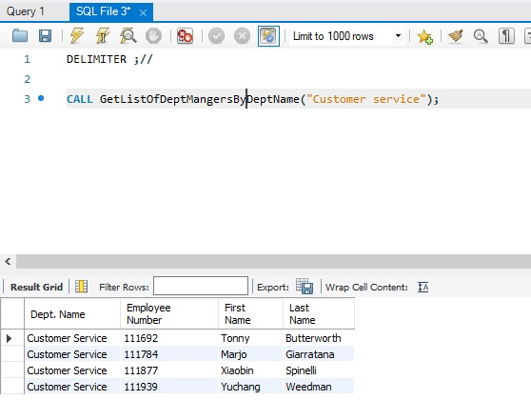

**URL to GitHub Repository:**